Frequently Asked Questions P-Cards
Purchasing Cards (P-Cards)
Questions (click link for detailed answers below)
1. How do I request access for a Pcard?
2. How do I request a credit card limit increase?
3. Who do I contact with questions regarding my chartfield?
4. If I’m locked out of my Pcard works account what do I do?
5. What do I do if my Pcard is declined by a vendor?
6. What do I do if my PIs Pcard is cancelled/lost?
7. What do I do after I upload my pcard receipt and update chartfield?
8. What items are allowed on the pcard?
9. What items are not allowed on the pcard?
10. How do I make sure the charges hit the correct chartfield?
11. What does a proper receipt include?
12. What do I do if it’s nearing the 15th of the month (sign-off deadline) and I haven’t received the receipt?
13. What happens if I miss the 15th sign-off?
14. What do I do if I find fraudulent charges on my card?
15. Where can I find resources?
Questions and Answers:

How do I request access for ePro?
For ePro access complete the “ConnectCarolina and Related Applications Access Request Form” found here.
Send to Laura Yurco for processing laura_yurco@unc.edu. You should be granted access within 3-4 business days. If you do not, please follow up.

How do I request a credit card limit increase?
The PI needs to contact his/her project manager and make the request; submit the request with the “P-Card Account Maintenance Form” found here.

Who do I contact with questions regarding my chartfield?
If you have questions about the various numbers (ex: source or fund), you may contact your PI’s admin support person.
If you have questions about the funding of the chartfield you want to use, you may contact the project manager that supports your PI.

If I’m locked out of my Pcard works account what do I do?
It’s most likely a limited time lockout so try again in 15 minutes. If you still can’t remember your password choose “reset password”

What do I do if my Pcard is declined by a vendor?
Check works to ensure you haven’t spent the full credit limit
Login to works and view on your home page the “available spend” amount.
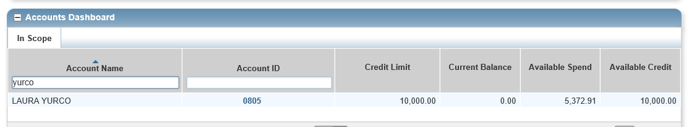
or
You can contact the Bank or Pcard administrator at pcard@unc.edu or 919-962-2255 for UNC to find out why the card was declined.

What do I do if my PIs Pcard is cancelled/lost?
You can contact the Pcard administrator at pcard@unc.edu or 919-962-2255 for UNC to request a new card.

What do I do after I upload my pcard receipt and update chartfield?
After uploading the receipt and updating the chartfield, ensure the receipt is readable and chartfield properly updated, then you will need to sign off. See section 11.1 of the Purchasing Card Program Handbook. The handbook can be accessed at the following link.
https://unc.policystat.com/policy/6151415/latest/

What items are allowed on the pcard?
https://unc.policystat.com/policy/6121678/latest/

What items are not allowed on the pcard?
https://unc.policystat.com/policy/6121678/latest/

How do I make sure the charges hit the correct chartfield?
Upload your receipt and edit chartfield accordingly regularly.
The cycle runs from the 16th to the 15th (ie: May 16th to June 15th), ensure sign-off for prior period is complete between 15th and 18th, the system generally closes out the prior period on the 20th of each month.

What does a proper receipt include?
The name of the vendor, date, amount and detailed information about what was purchased.

What do I do if it’s nearing the 15th of the month (sign-off deadline) and I haven’t received the receipt?
Update the chartfield, attach an order confirmation or blank document and sign-off (don’t forget to go back once receipt is received to replace attachment).

What happens if I miss the 15th sign-off?
The charge will likely hit the wrong chartfield and will need to be corrected on the back-end; let your research administrator know.
Also, you should still go into works to attach the receipt and sign-off (but you won’t have the ability to update the chartfield)

What do I do if I find fraudulent charges on my card?
Call the bank (# is listed on your card). The bank will not remove the charge but place a credit on your card. Don’t forget you must still sign-off on these charges

Where can I find resources?
https://finance.unc.edu/departments/training/#pane-0-3

